A000-AFR-EGY-Akenaton-Head-Amarna-1351–1334 BCE

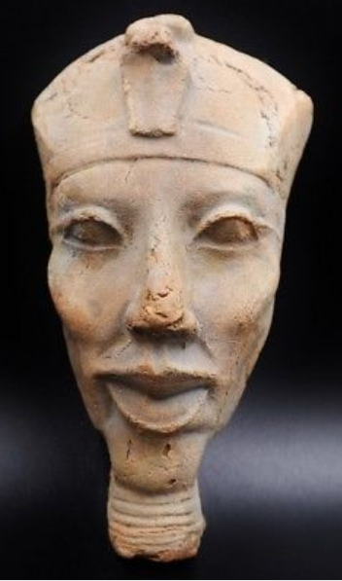

**Case No.: 2**

**Accession No.**

**Formal Label:**

**Display Description:**

This sculpted head of PharaohAmen-Hotep IV (r. 1351–1334 BCE) was produced by an élite sculptor in the late Eighteenth Dynasty of the New Kingdom. This sculpture is of a leader who determined in his early youth to fight against "the selfish and the strong," since at the time much of the political power was held by priests whose chief deity was Amen or Amon (the first part of the pharaoh’s name). The allegiance of the priests was to their Amon cult and not to the Pharaoh, Amen-Hotep IV’s father, Amen-Hotep III. Amen-Hotep IV saw the tyranny behind the throne, and, before his own ascension to it, he began to develop a monotheistic cult centered on Aten, perhaps suggested by his grandfather. Aten’s symbol was the solar disc, but Aten was not the material Sun: rather, He was regarded as the First Cause, a philosophical principle, one which harkened back to the unification of Egypt in the Old Kingdom when Ra, the Sun god, was the unifying deity of the people. Akhen-Aten IV ascended the throne with a passion to end the priestly tyranny and to make his kingdom "wise, and just.” In the face of strenuous Hittite military campaigns that were exploding against unruly Syrian princes in the north, Thebes received ominous reports of southward Hittite campaigns already advancing on Palestine.

In this age of turmoil, Amenhotep IV broke with the past in five significant ways.

First, he discouraged polytheism for a type of monotheism in which he focused on the worship of Aten. Behind his monotheism may have been the rubric, one god one people.

Secondly, he had a new city built -- Akhet-Aten, "Horizon of Aten," -- on the east bank of the Nile River, 312 miles south of the modern city of Cairo, in which a large temple to Aten and other ceremonial buildings associated with Aten worship were constructed. (In modern times this city has been known as Amarna for the Beni Amran tribe that lived in the vicinity when the first excavations were being initiated in the early 1900’s.)

Thirdly, henceforth no other Egyptian gods except Aten were permitted to be worshipped.

Fourthly, in Month 7, in the fifth year of his reign, he changed his name to Aken-Aten, “he who worships Aten,” and on day 13, Month 8, he entered Akhet-Aten, and vowed never to leave it.

Fifthly, the art style that was espoused in Akhet-Aten broke with the traditional Egyptian art style that had been the normative since the Old Kingdom with its rigid symmetry, blocky use of volumes for human subjects and strictly proportional volumes for human bodies. The Akhet-Aten art style (or Amarna art style as it is better known) dispensed with these conventions and substituted idiosyncrasies that can be seen in this sculpture of Aken-Aten’s head. It was sculpted probably by one of the élite sculptors who lived in the main city and not in the workmen’s precinct (Kemp 1987: 46). In this example we can see Aken-Aten’s distinctly elongated face with unusually large lips and prominent cheeks.

**Accession Number:**

**LC Classification:**

**Date or Time Horizon:** Dynasty 18, ca.1340 BCE

**Geographical Area:** Amarna

**Map:**

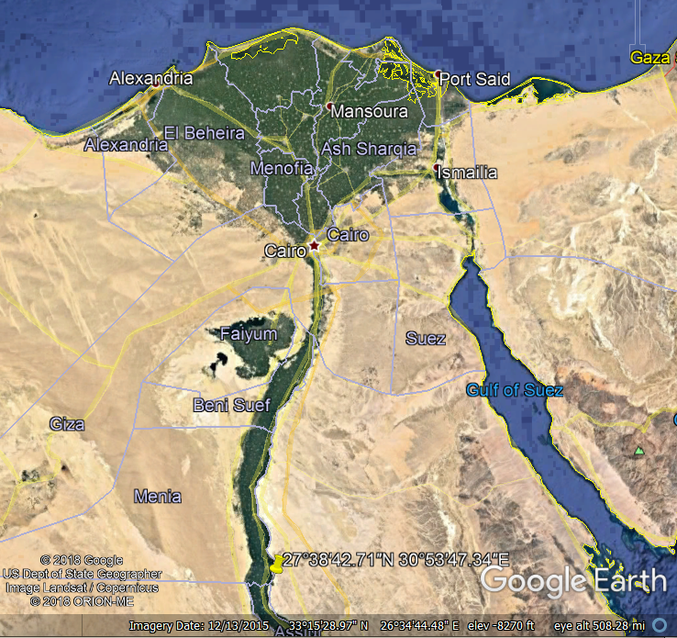

**Location of Amarna in Egypt.**



Amarna reconstruction by [Joan Lalucat and Adrià Turina](https://commons.wikimedia.org/w/index.php?title=User:Joan_lalucat&action=edit&redlink=1) in 2014 of the Escola d'Art del Treball. After https://upload.wikimedia.org/wikipedia/commons/thumb/f/f2/Amarna_2.jpg/1200px-Amarna_2.jpg

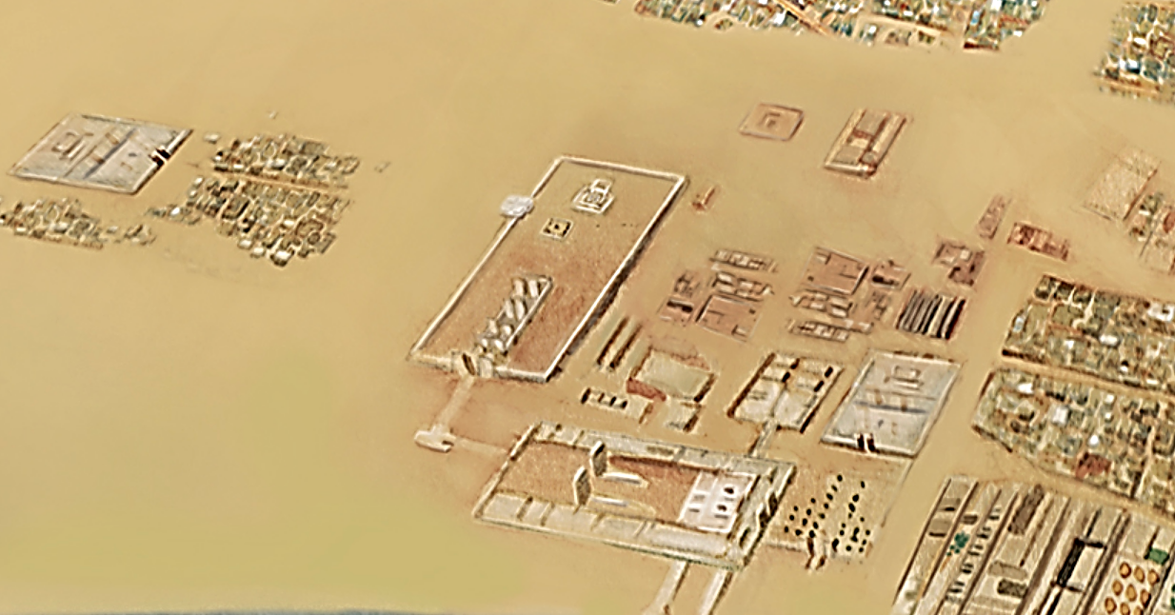

**Amarna** reconstruction by [Joan Lalucat and Adrià Turina](https://commons.wikimedia.org/w/index.php?title=User:Joan_lalucat&action=edit&redlink=1) in 2014 of the Escola d'Art del Treball. After https://upload.wikimedia.org/wikipedia/commons/thumb/f/f2/Amarna_2.jpg/1200px-Amarna_2.jpg



**Map of the area around the Workmen's Village.**

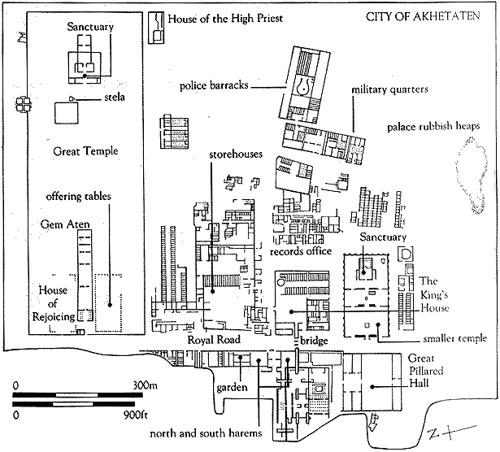

City of Akhetaten after http://www.newtowninstitute.org/newtowndata/NTimages/central_city_of_akhetaten.gif

**GPS coordinates:** [27°38′42.71″N 30°53′47.34″E](https://tools.wmflabs.org/geohack/geohack.php?pagename=Amarna&params=27_38_42.71_N_30_53_47.34_E_type:landmark)

**Cultural Affiliation:**

**Media:**

**Dimensions:**

**Weight:**

**Condition:**

**Provenance:**

**Discussion:**

Other characteristics of Aken-Aten’s physiogamy include his exaggerated breasts, stomach, large hips and thighs that mirror the same feminine physiogamy as his wife.

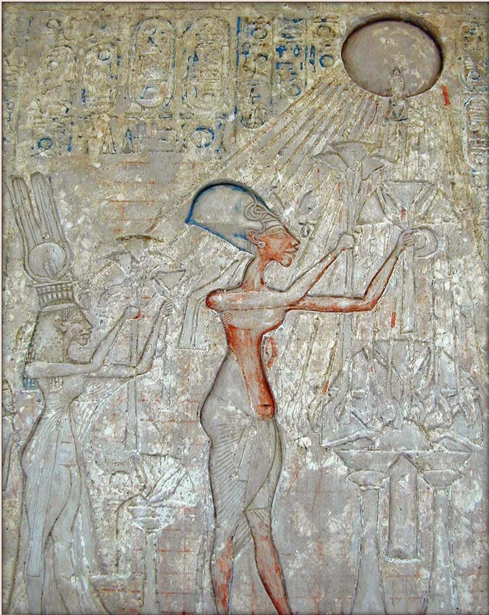

Pharaoh Akhenaten (center) and his wife, left, worshiping [Aten](https://en.wikipedia.org/wiki/Aten), whose rays emanate from the solar disk and terminate with hands. This panel is in the Akenaten room of the Cairo Museum. It was photographed by [Jean-Pierre Dalbéra](https://www.flickr.com/people/72746018@N00) from Paris, France, and <http://jdalbera.free.fr/thebes_2002_web/musee_caire/index1.htm>.

The following sculpture of Aken-Aten displays some of the same features in the face that is found in the sculpture of his head.

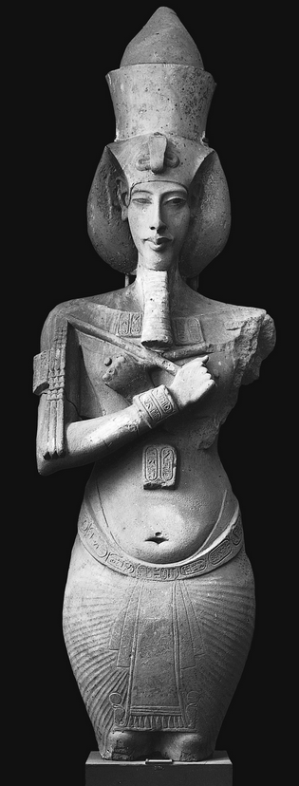 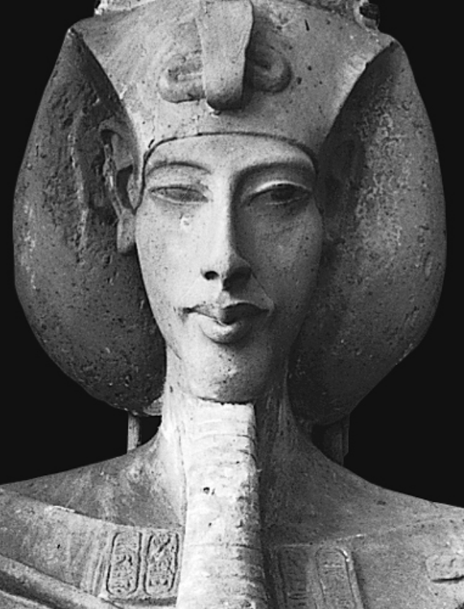

Aken-Aton in the Luxor Egyptian Museum after http://revelationnow.net/wp-content/gallery/akhenaten/akhenaten_hips.fw_.png

**References:**

Kemp, B.J., 1987. The Amarna Workmen's village in retrospect. *The Journal of Egyptian Archaeology*, *73*(1), pp.21-50